Sales Prediction Dataset

Questions:
- What is the average amount spent on TV advertising in the dataset?

147.0425

- What is the correlation between radio advertising expenditure and product sales?
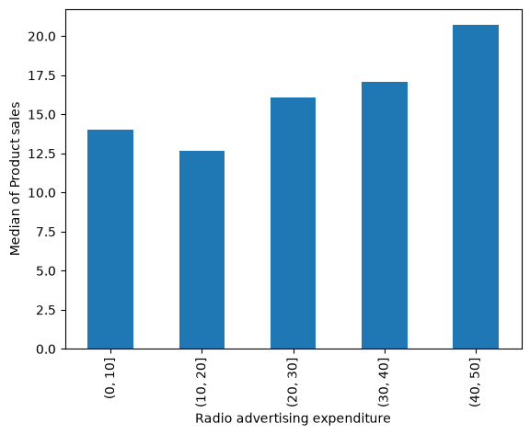

- Which advertising medium has the highest impact on sales based on the dataset?
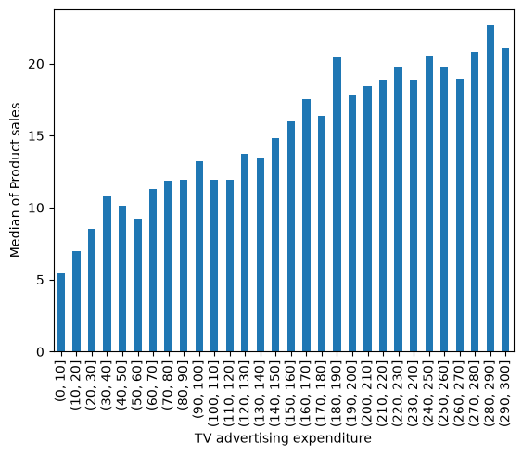
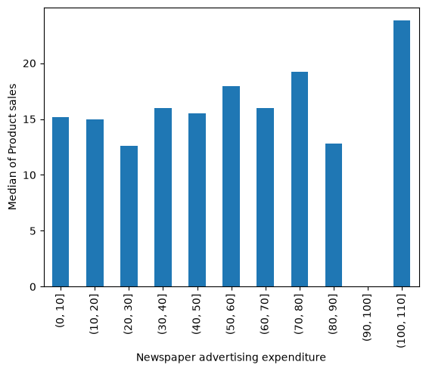

- Plot a linear regression line that includes all variables (TV, Radio, Newspaper) to predict Sales, and visualize the model's predictions against the actual sales values.
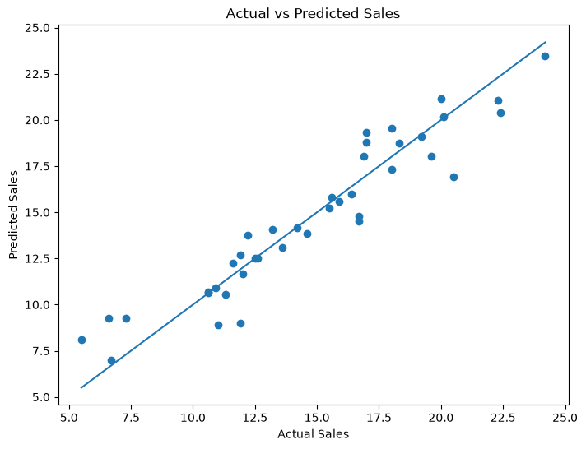
- How would sales be predicted for a new set of advertising expenditures: $200 on TV, $40 on Radio, and $50 on Newspaper?
Predicted sales = 19.8195841

- How does the performance of the linear regression model change when the dataset is normalized?
The linear regression model was trained on both the original dataset and the normalized dataset using Min-Max Scaling. The R² score obtained in both cases was 0.89910282638328.
Since the R² score remained exactly the same after normalization, it can be concluded that normalization did not affect the predictive performance of the linear regression model.

- What is the impact on the sales prediction when only radio and newspaper advertising expenditures are used as predictors?
A new linear regression model was trained using only Radio and Newspaper advertising expenditures as predictor variables. The resulting model achieved an R² score of -0.0519, compared to 0.8991 for the original model that included TV advertising.
The negative R² score indicates that the reduced model performs worse than a baseline model that simply predicts the average sales value for all observations. This demonstrates that Radio and Newspaper expenditures alone are not sufficient to accurately predict sales.

